**D.K.T.E. Society’s Textile and Engineering Institute, Ichalkaranji.**

**(An Autonomous Institute)**

DEPARTMENT OF INFORMATION TECHNOLOGY

2019-2020



Project report on

*Student Attendance Management System*

**Under the guidance of**

***Faculty name-M.A. Khanaj***

**Group Members:**

* **Shrutika Patil 17uit11053xx**
* **Palak Somani 17uit51054xx**
* **Anuja Mane 17uit51058xx**
* **Rutuja Magdum 17uit51060xx**
* **Sayali Pote 16uit11042xx**
* **D.K.T.E. Society’s Textile and Engineering Institute, Ichalkaranji**

**(An Autonomous Institute)**

Department of Information Technology

CERTIFICATE

This is to certify that

* **Shrutika Patil 17uit11053xx**
* **Palak Somani 17uit51054xx**
* **Anuja Mane 17uit51058xx**
* **Rutuja Magdum 17uit51060xx**
* **Sayali Pote 16uit11042xx**

We successfully completed the mini project work, entitled,

*Student Attendance Management System*

in partial fulfillment for the award of degree of Bachelor of Technology in Information Technology. This is the record of their work carried out during academic year 2019-20.

Date: Place: Ichalkaranji

*M.A. Khanaj* Prof. (Dr.) D. V. Kodavade

[Project Guide] [Head of Department]

Prof. (Dr.) P.V. Kadole

**[Director/Principal]**

**DECLARATION**

We the undersigned students of T.Y. B. Tech I.T. declare that, the field work report entitled ***Student Attendance Management System*** written and submitted under the guidance of ***Prof.M.A. Khanaj*** is our original work. The empirical findings in this report are based on the data collected by us. The matter assimilated in this report is not reproduction from any readymade report.

Date:

Place: Ichalkaranji.

Name Signature

* **Shrutika Patil**
* **Palak Somani**
* **Anuja Mane**
* **Rutuja Magdum**
* **Sayali Pote**

**INDEX**

**CONTENTS PAGE**

1. Abstract 5
2. Problem Statement 6
3. Problem Description
4. Requirement Specification 7
5. Requirement Analysis 8

5.1 Functional Requirements 9

5.2 System Requirements 10

1. System Design

6.1 Architectural Design 11

6.2 Flow Chart 12

6.3 Class Diagram 13

6.4 Dataflow Diagram 14

6.5 Use case Diagram 15

6.6 Activity Diagram 16

6.7 Collaboration Diagram 17

1. Implementation 18
2. Testing 19
3. Snap shots 20
4. Conclusion 23
5. References 24

**1.ABSTRACT**

Student attendance management system deals with the maintenance of the student’s attendance details. It generates the attendance of the student on basis of presence in class. It is maintained on the daily basis of their attendance. The staffs will be provided with the separate username & password to make the student’s status. And students are also provided with username and password.

The staffs handling the particular subjects responsible to make the attendance for all students. Only if the student present on that particular period, the attendance will be calculated. The student’s attendance reports based on weekly and consolidate will be generated.

**PROBLEM STATEMENT**

Attendance Management System is software developed for daily student attendance in schools, colleges and institutes. It facilitates to access the attendance information of a particular student in a particular class. This system will also help in evaluating attendance eligibility criteria of a student. By just a click on the mouse, the system will be able to produce the students' attendance report thus reducing the need for manual labour which is prone to human errors and time consuming.

This application is built for automating the processing of attendance. It also enhances the speed of performing attendance task easily.

**PROBLEM DESCRIPTION**

The system will reduce the manual work and avoid redundant data.by maintenance the attendance manually, then efficient reports cannot be generated. The system can generate efficient weekly, consolidate report based on the attendance, As the attendance are maintained in registers it has been a tough task for admin and staff to maintain for long time. Instead the software can keep long and retrieve the information when needed.

**REQUIREMENT SPECIFICATION**

In requirement specification there 2 types of requirement software requirement and hardware requirement:

Hardware Requirement:

RAM: 2GB

Hard disk: 500GB

Processor: Intel core i5

Software Requirement:

Operating system: Windows 10

Frontend design: Visual studios 2008

Front-end language: VB.NET

Back-end language: MySQL

**REQUIREMENT ANALYSIS**

According to the requirements the system should minimum generate following kinds of reports. List of report is give below

* Semester wise Attendance
* Daily Attendance
* Attendance for extra class
* Subject wise attendance
* Black listed below 75%

**SYSTEM DESIGN**

**6.1 ARCHITECTURAL DESIGN**

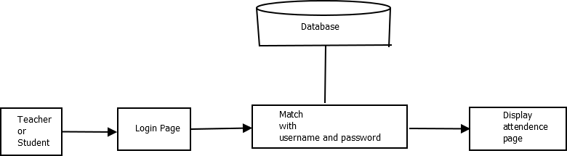

**6.2 FLOWCHARTS**

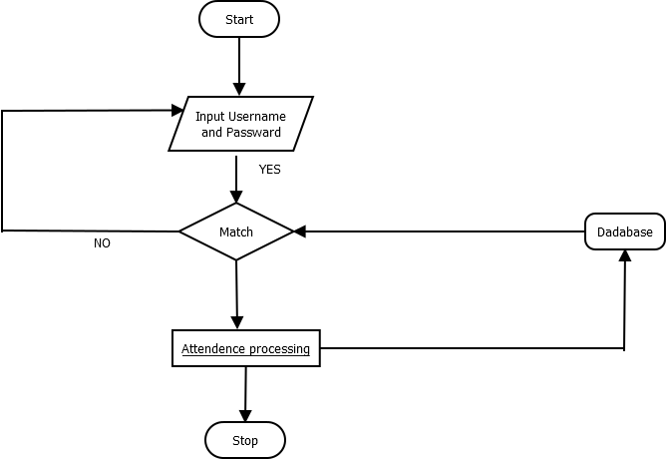

**6.3 CLASS DIAGRAM**

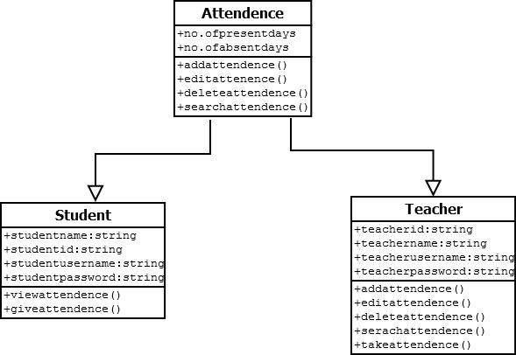

**6.4 DATA FLOW DIAGRAM**

**Level0:**

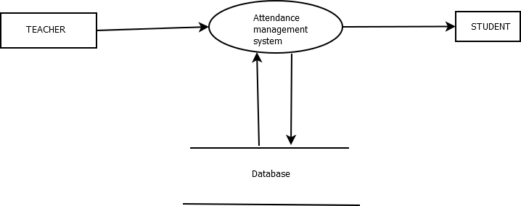

**Level1:**

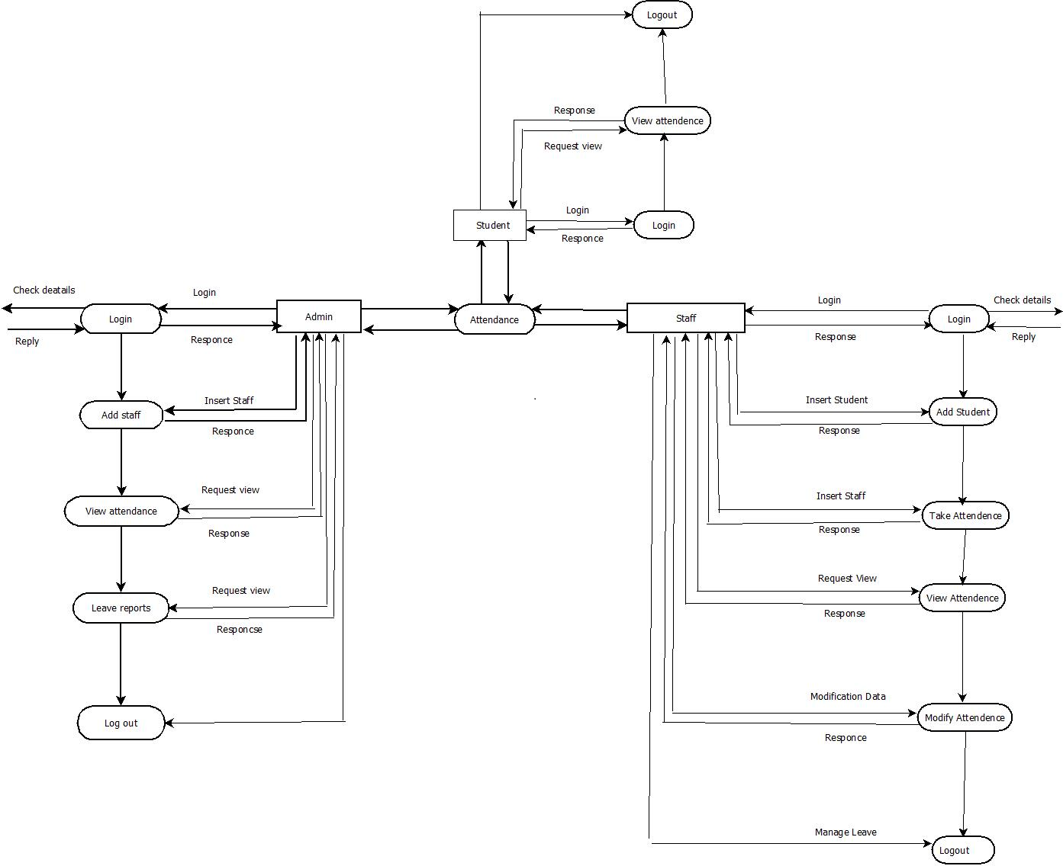

**6.5 USE CASE DIAGRAM**

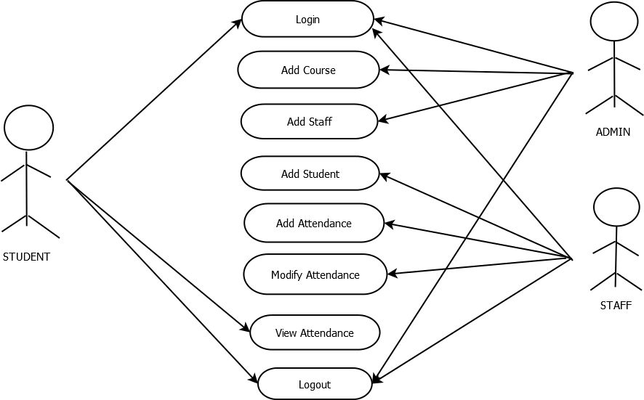

**6.6 ACTIVITY DIAGRAM**

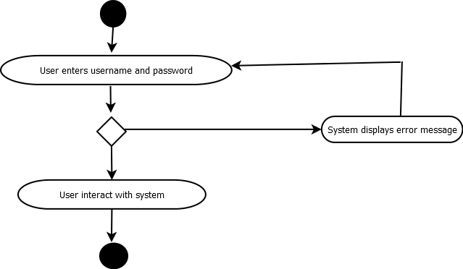

**6.7 COLLABORATION DIAGRAM**

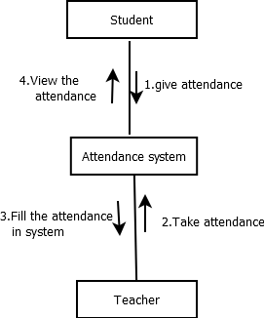

1. **IMPLEMENTATION**

Input: username and password to the attendance management system

Function: login page

Input: username and password

Output: displays student page

Description:

Function: login page

Input: username and password for teacher

Output: displays teacher page

Description: when teacher enters username and password the software displays teacher page so that teacher can add attendance.

Function: teacher page

Input: subject, session, attendance status of students

Output: attendance stored to the database

Description: when teacher submits attendance, the software stores the attendance to the database.

Function: attendance page

Input: user name and password

Output: displays attendance page to the user

Description: After the checking of username and password the system displays the attendance page to the corresponding user may be teacher or student.

**TESTING**

|  |  |  |  |  |
| --- | --- | --- | --- | --- |
| Case ID | Test cases | Expected Output | Actual Output | Result Pass/fail |
| 1 | Input: username and password of student | Student window should display | Student window displayed. | Pass |
| 2 | Input: username and password of Teacher | Teacher window should display | Teacher window displayed. | Pass |
| 3 | View attendance button | Displays attendance of student | Displays attendance of student | Pass |

1. **SNAP SHOT**

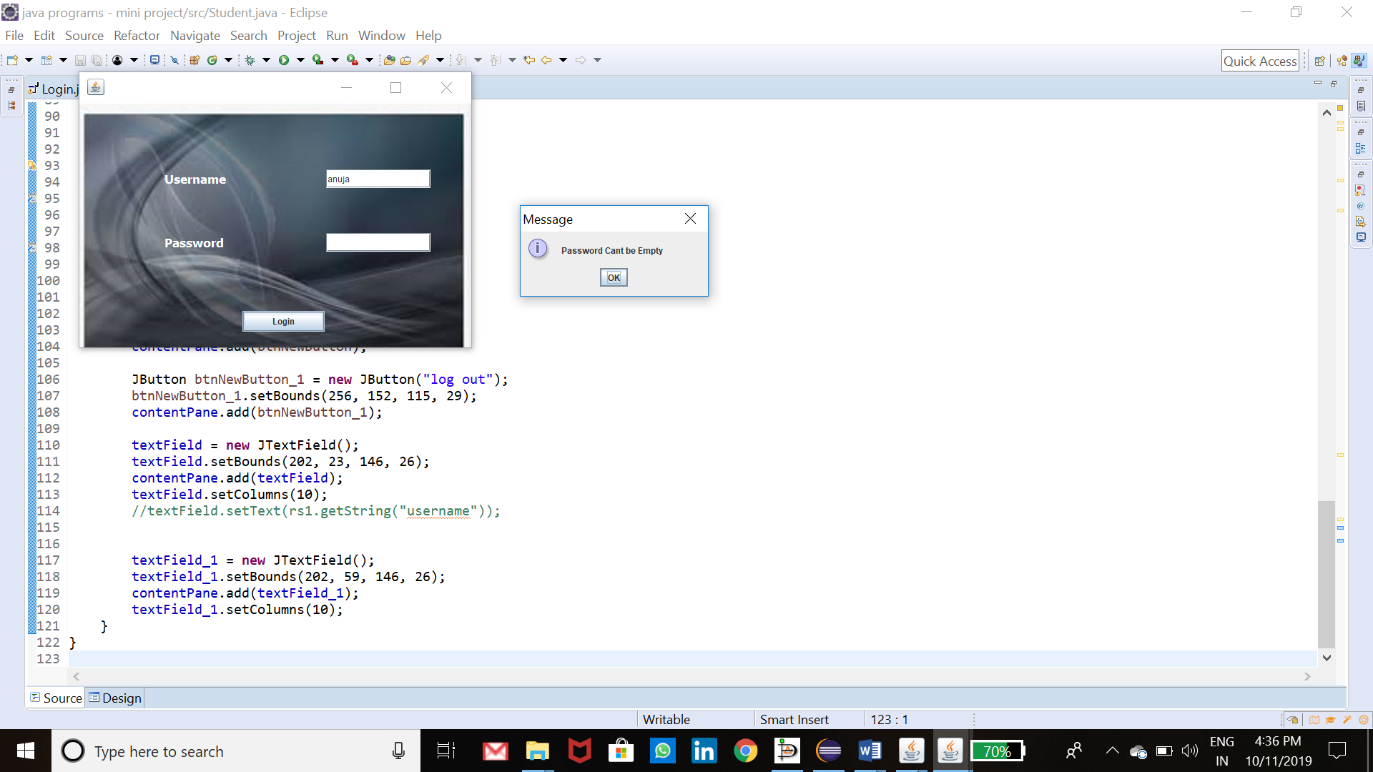

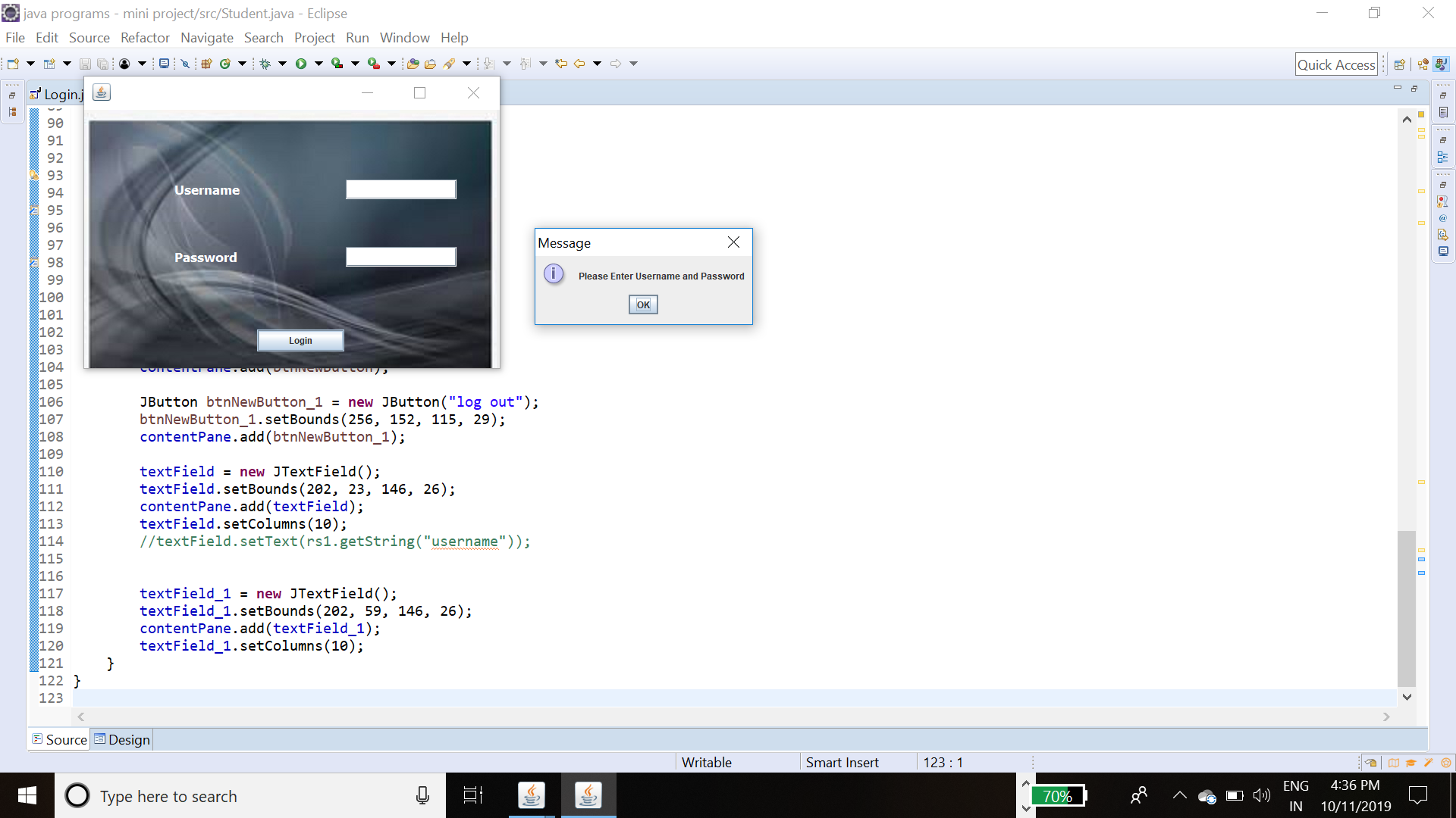

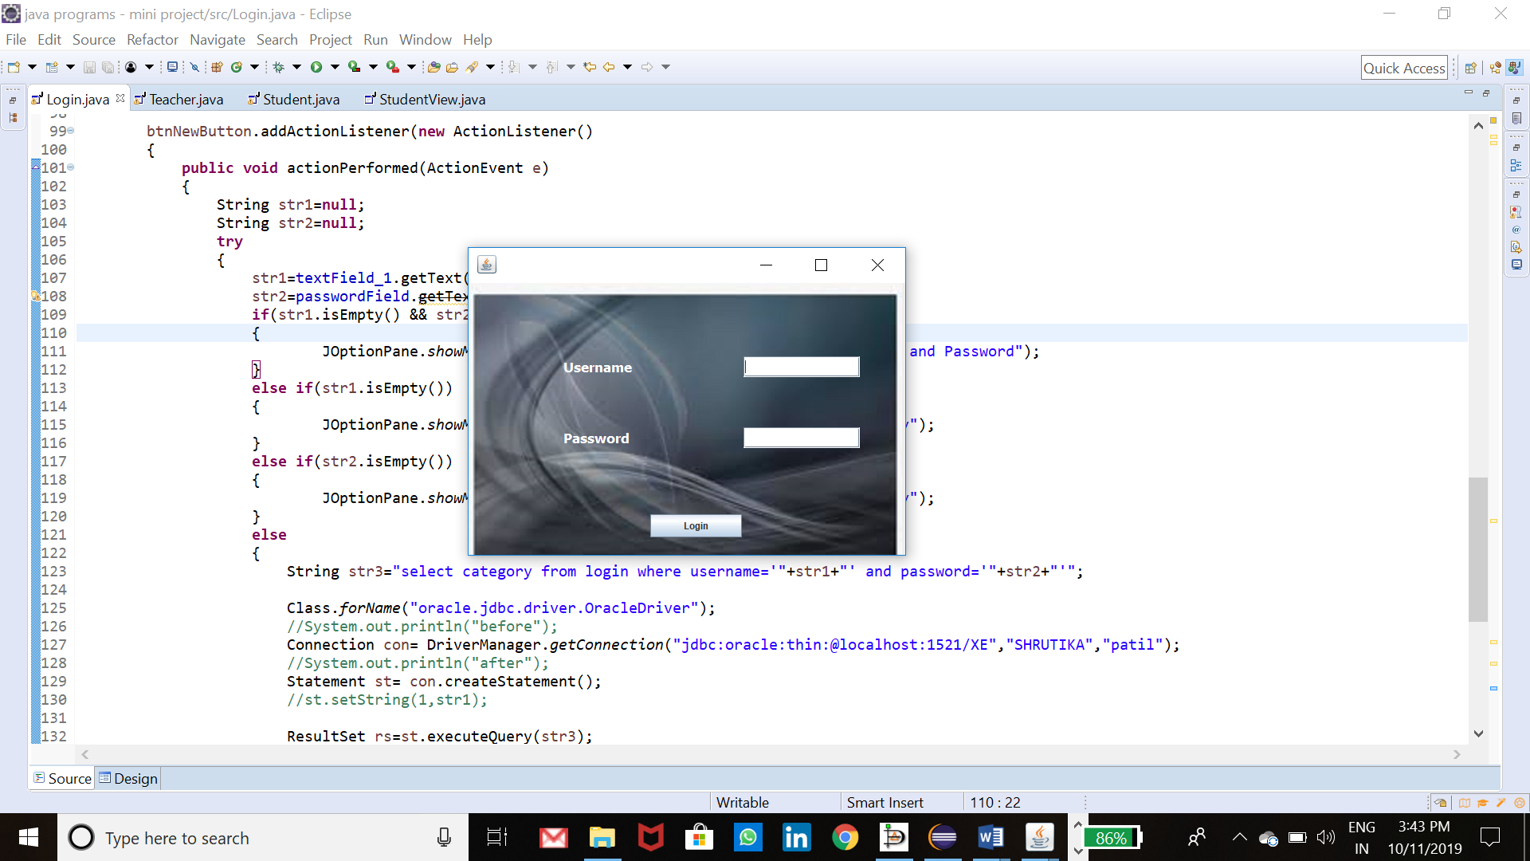

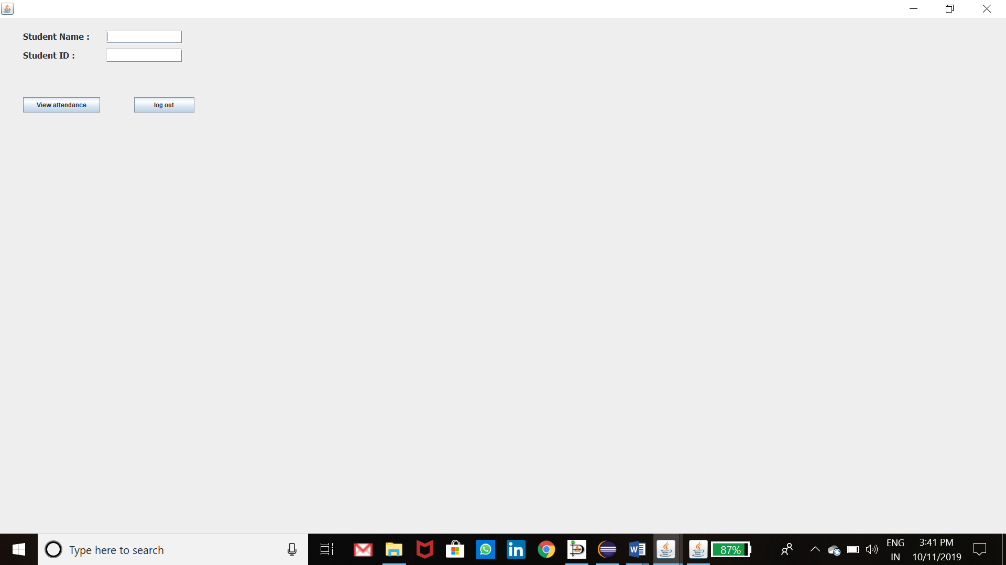

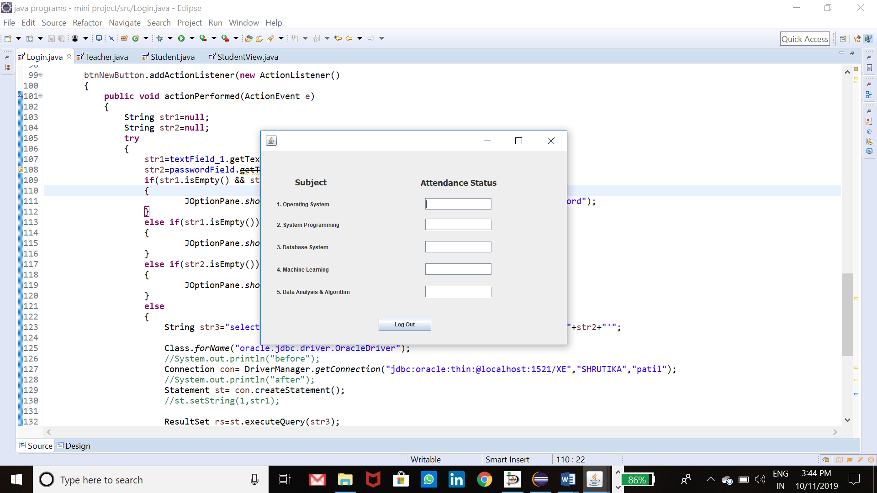



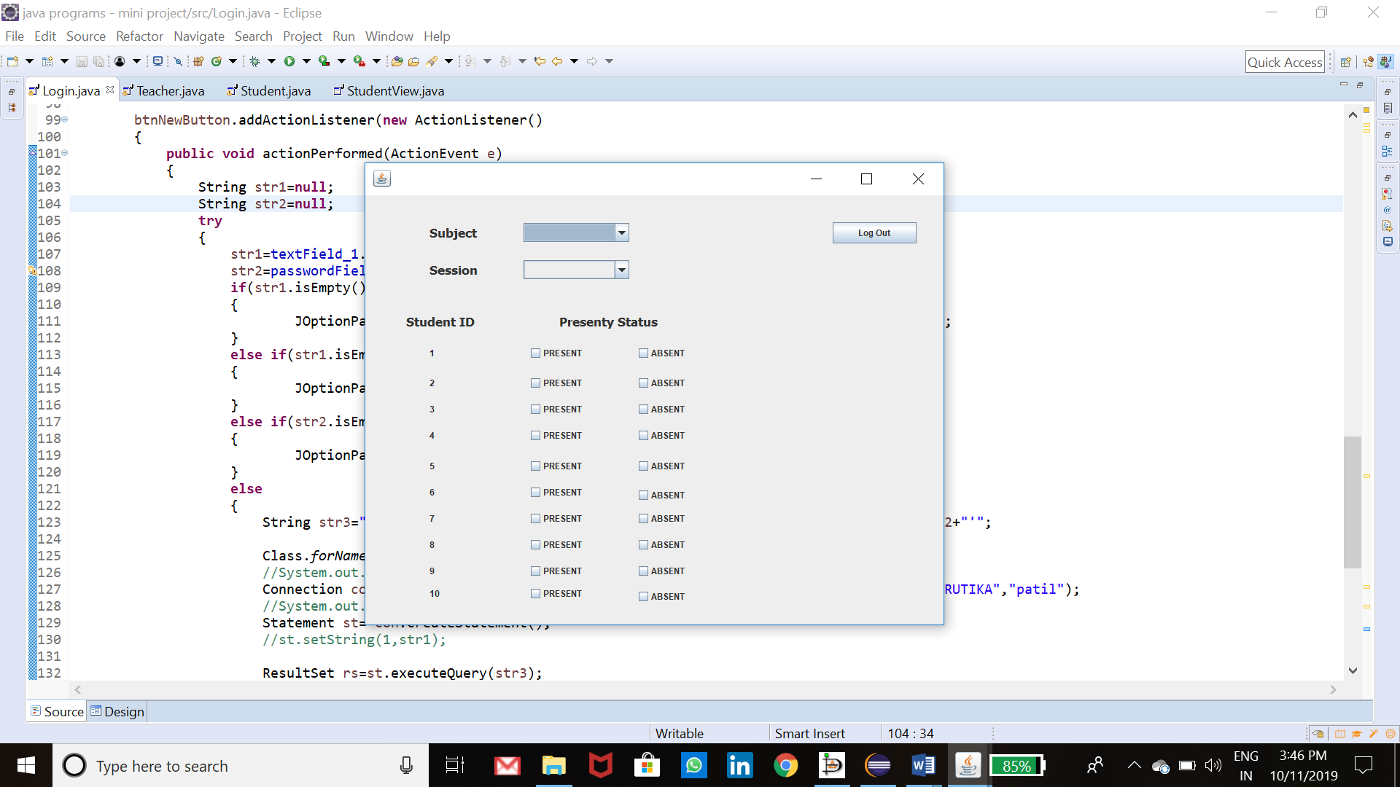

**CONCLUSION**

This software has its advantages and disadvantages but it can surly help with the record storage system. we don’t have to worry about the misplace of record which is a great clash while storing record on separate files. This project has very scope in future. As this system is very useful for college to maintain the attendance record. This attendance management system is using the login mechanism by using the user name and password.

1. **REFERENCES**

<http://www.stackoverflow.com>

<http://www.javapoint.com>

<http://www.tutorialspoint.com>

<http://blog.oracle.com>